Capstone Project Weekly Progress Report
Semester | Fall-2024 Semester 3rd
Course Code | AML-3406
Section | Section 1
Project Title | Car Damage Detection
Group Name | Group B
Student names/Student IDs | Sakshi (C0908000) – TL  Bansil Patel (C0912873)  Harsh Mohile (C0912872)  Meet Patel (C0910378)  Rachit Bhatt (C0902810)
Reporting Week | Week 12
Faculty Supervisor | William Pourmajidi

Grade the level of collaboration from different aspects between team members:
(use: good, medium, below expectation)
Sakshi | Bansil Patel | Harsh Mohile | Meet Patel | Rachit Bhatt
Good | Good | Good | Good | Good

Tasks outlined in the previous Weekly Progress Report for this reporting week at the individual level and group level
  - Individual tasks (each team member)
Sakshi: Enhance the GitHub Actions pipeline by adding real-time monitoring and alerting features to track deployment status.
Bansil Patel & Meet Patel: Plan to expand testing with more diverse datasets, focusing on rare car damage types for improved model generalization.
Harsh Mohile & Rachit Bhatt: Further optimize the Deployment UI to improve user experience and make it more intuitive for end users.
2.2 Your team’s tasks
- Model Enhancements: Plan to explore advanced model architectures to improve accuracy, aiming for higher performance in detecting complex car damages.
- Deployment Pipeline: Add real-time monitoring to the deployment pipeline, enabling better tracking of deployment success and quick rollback if needed.
- UI Optimization: Improve the Deployment UI with new features such as interactive visualizations of model predictions and user feedback integration.
- Scalability: Focus on optimizing the model's performance for large-scale data processing to handle a wider variety of car images in real-world applications.

Progress made in Reporting Week at an individual level and group level
  - Individual progress
Sakshi: Resolved repository configuration issues to ensure consistent deployments.
Bansil Patel & Meet Patel: Validated the model's robustness by testing on multiple datasets, confirming its generalization to different car damage types.
Harsh Mohile & Rachit Bhatt: Conducted extensive testing across staging and production environments, ensuring reliable performance.
  - Your team’s progress
- Finalized the automated deployment pipeline with GitHub Actions, ensuring smooth deployments across all environments. Fully integrated the UI with the backend, ensuring seamless deployment in staging and production.

The areas/tasks you could not make progress and/or complete as scheduled or the difficulties encountered in this reporting week at individual level and group level.
  - Individual project blockers
Sakshi: Minor integration issues were resolved by refining repository configurations.
Bansil Patel & Meet Patel: Delays in backend-UI communication but resolved during testing.
Harsh Mohile & Rachit Bhatt: N/A.
4.2Your team’s project blockers
- Multi-branch setup caused delays, resolved with configuration adjustments.
- Minor adjustments to align the UI with production configurations.

Tasks to be completed in the next week at the individual level and group level
  - Individual tasks
Sakshi, Bansil Patel & Meet Patel: N/A
Harsh Mohile & Rachit Bhatt: N/A

  - Your team’s tasks

The project has been completed successfully.

Include the tasks from your sprint planning (GitHub/ZenHub) for the present period.
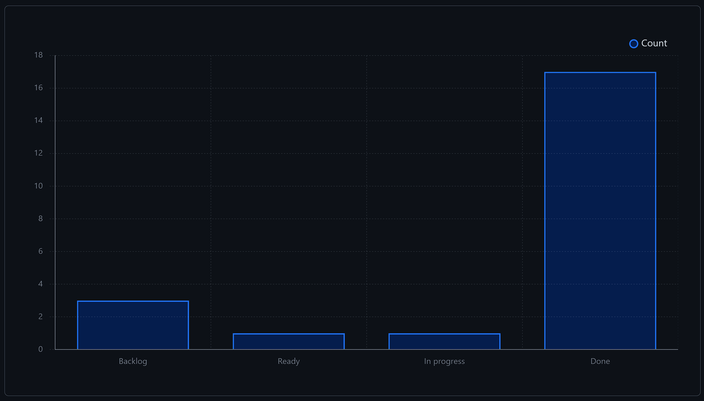
Figure 1: Weekly Activities
- In this week, there were a lot of issues resolved from the backlog, contributing to development.

Include charts/graphs (e.g., burn down charts) from your project management tool (Github/Zenhub) that shows your progress for the period of this report.
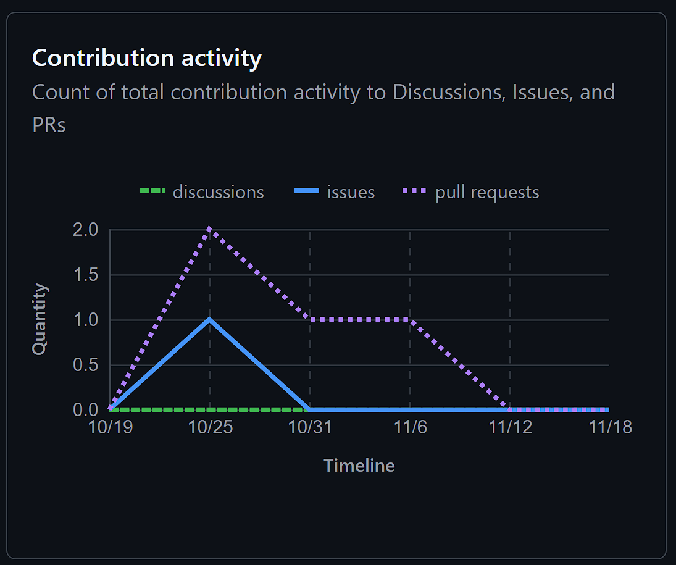
Figure 2: Contributors in the Week
- This week, we had a few PRs and issues resolved as compared to previous week, demonstrating team hard work and dedication.

Include a note and address to your project GitHub with list of codes uploaded/updated on GitHub in this reporting week.
GitHub: https://www.github.com/rachit-bhatt/Capstone-Project

